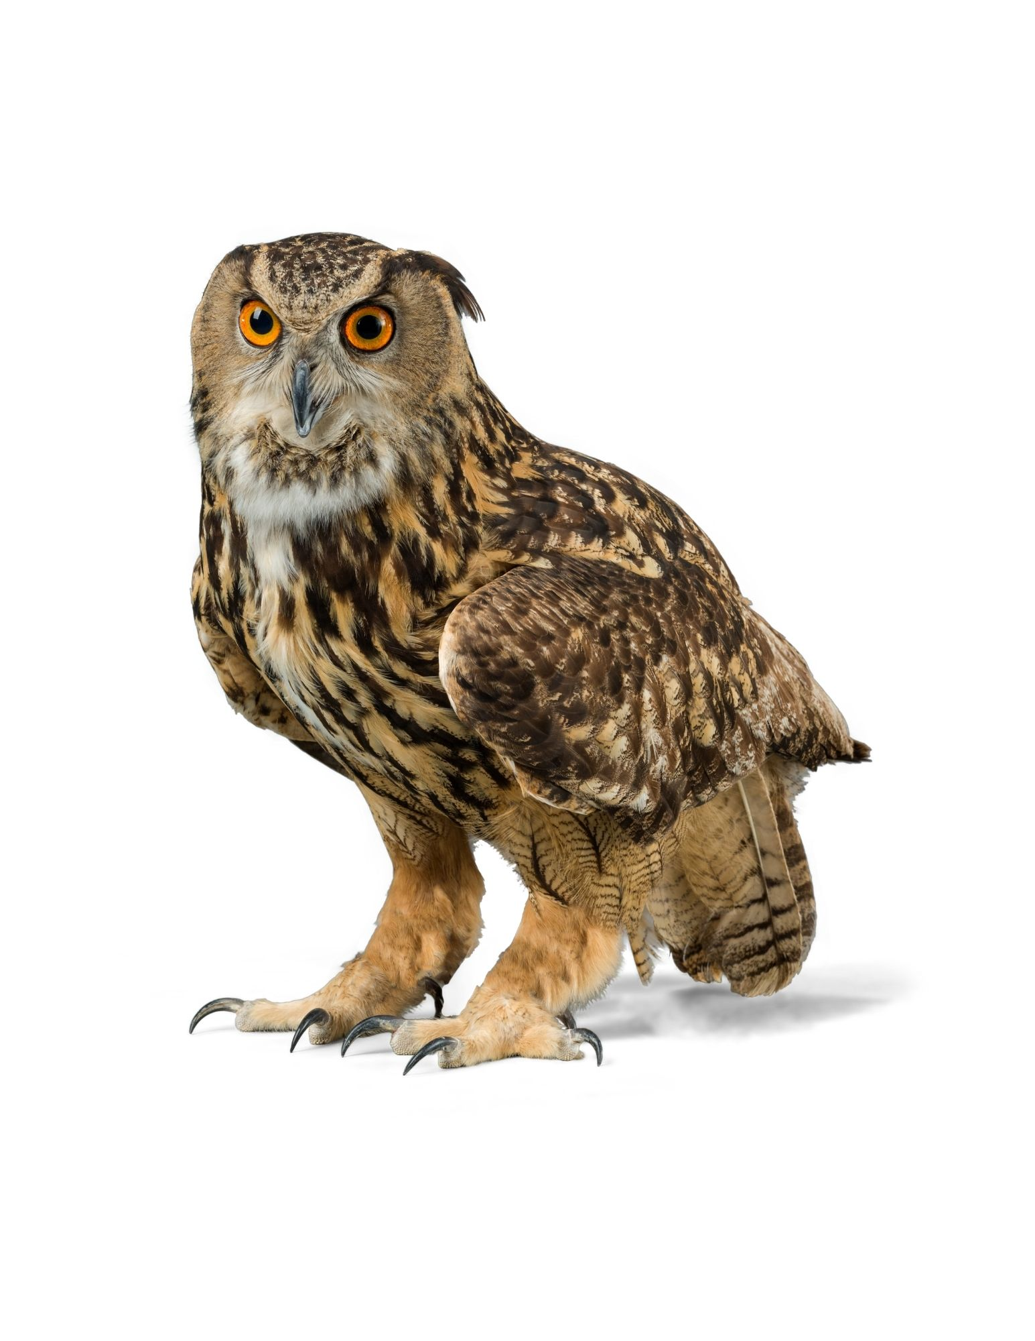

***Great Horned Owl***

Size:

Habitat:

Fact3:

RORY’S BACKYARD:

HIDDEN IN PLAIN SIGHT

AUGMENTED REALITY GAME

YOU FOUND X ANIMALS

Your Journal:







RORY’S BACKYARD:

HIDDEN IN PLAIN SIGHT

AUGMENTED REALITY GAME

Florida is home to many kinds of native wildlife that use their ability to camouflage to stay safe from predators.

Collect pictures of these animals by centering your camera on the animals you find until you see a flash. See if you can find all 9 hidden animals in than a minute!

START!